Hospital Appointment No-Show Analytics Using Microsoft Azure

BY – PAVAN KUMAR KN

1. Introduction
Hospitals and healthcare institutions depend on appointment-based systems to manage patient visits, optimize doctor schedules, and utilize medical infrastructure efficiently. However, a significant operational challenge faced by hospitals is the issue of patient no-shows, where patients fail to attend scheduled appointments without prior cancellation. These no-shows lead to underutilization of medical staff, increased waiting times for other patients, revenue loss, and inefficient healthcare delivery.
With the growth of digital healthcare systems, hospitals now generate large volumes of data related to appointments, patients, and clinical operations. Traditional reporting tools are insufficient to process and analyze this data effectively. Cloud computing and data analytics platforms offer scalable, reliable, and cost-effective solutions to extract meaningful insights from healthcare data.
This project leverages Microsoft Azure cloud services to design and implement a complete analytics pipeline for understanding hospital appointment no-show behavior.

2. Problem Statement (Expanded)
Despite having digital appointment systems, many hospitals lack advanced analytics to understand why patients miss appointments. The absence of automated data pipelines and dashboards makes it difficult to:
- Identify departments with high no-show rates
- Analyze the impact of appointment lead time
- Measure the effectiveness of reminders
- Make data-driven scheduling decisions
Manual data analysis is time-consuming, prone to errors, and not scalable. Therefore, an automated, cloud-based analytics solution is required to address these challenges.

3. Objectives of the Project (Detailed)
The key objectives of this project are:
- To build an end-to-end data analytics pipeline using Microsoft Azure
- To automate ingestion of hospital appointment data
- To store data securely and efficiently using cloud storage
- To perform large-scale data transformations using PySpark
- To calculate meaningful healthcare KPIs
- To visualize insights using interactive dashboards
- To support operational and strategic decision-making

4. Importance of No-Show Analytics
No-show analytics plays a critical role in healthcare management:
- Reduces appointment wastage
- Improves doctor utilization
- Enhances patient satisfaction
- Supports better capacity planning
- Reduces operational costs
By understanding no-show patterns, hospitals can design proactive interventions such as automated reminders or overbooking strategies.

5. Literature Review (Detailed)
Multiple healthcare studies indicate that patient no-shows are influenced by:
- Long appointment lead times
- Appointment time of day
- Lack of reminders
- Patient demographics
- Booking channels
Recent research also highlights the adoption of cloud-based analytics platforms as an effective approach to handling healthcare data due to scalability and security.

6. System Architecture (Detailed Explanation)
The system architecture follows a layered cloud-based design:

6.1 Data Source Layer
- Synthetic CSV files representing appointments, patients, doctors, and departments

6.2 Data Ingestion Layer
- Azure Data Factory (ADF) Copy Data pipelines

6.3 Storage Layer
- Azure Data Lake Gen2 with raw and curated containers

6.4 Processing Layer
- Azure Databricks using PySpark

6.5 Visualization Layer
- Power BI dashboards
This architecture ensures separation of concerns and scalability.

7. Azure Data Factory – Data Ingestion
Azure Data Factory is a cloud-based ETL service used to orchestrate and automate data movement. In this project:
- CSV files are ingested from the source
- Data is copied from raw to curated containers
- Pipelines are triggered manually for testing
ADF ensures data availability for downstream analytics.

8. Azure Data Lake Gen2 – Storage Layer
Azure Data Lake Gen2 provides:
- Hierarchical namespace support
- High availability and durability
- Secure access using Azure Active Directory
The project uses:
- Raw container: stores unprocessed data
- Curated container: stores cleaned and standardized data

9. Azure Databricks – Data Processing
Azure Databricks is used for:
- Reading data directly from ADLS using abfss://
- Cleaning missing and inconsistent values
- Standardizing appointment status
- Joining multiple datasets
- Calculating KPIs
Databricks supports distributed processing using Apache Spark.

10. PySpark Transformations (Expanded)
Key transformations include:
- Filtering no-show appointments
- Calculating no-show percentages
- Grouping by department, time slot, and day
- Deriving lead-time based trends

Example:
noshow_rate = appointments.filter(
appointments.status == "No-Show"
).count() / appointments.count() * 100

11. KPI Definitions (Detailed)

11.1 Overall No-Show Rate
Percentage of total appointments marked as "No-Show".

11.2 Department-wise No-Show Rate
Helps identify departments requiring intervention.

11.3 Time Slot Analysis
Determines peak no-show periods during the day.

11.4 Lead Time Impact
Longer booking gaps often correlate with higher no-shows.

11.5 Reminder Effectiveness
Compares attendance between reminder-sent and non-reminder appointments.

12. Power BI Visualization (Expanded)
Power BI dashboards include:
- KPI cards for quick overview
- Bar charts for departmental analysis
- Line charts for temporal trends
- Slicers for dynamic filtering
These dashboards provide interactive insights to management.

13. Results and Observations
Key observations:
- Certain departments experience consistently high no-show rates
- Morning and late evening slots show higher no-shows
- Reminder-sent appointments have lower no-show rates
- Longer lead times increase no-show probability

14. Business Impact (Expanded)
This analytics solution helps hospitals:
- Reduce financial losses
- Improve patient flow management
- Optimize staff scheduling
- Improve patient communication strategies

15. Security and Compliance
Azure services ensure:
- Secure data storage
- Controlled access
- Compliance with healthcare data standards

16. Limitations
- Synthetic dataset
- No real-time streaming
- No predictive modeling

17. Future Enhancements (Expanded)
Future improvements include:
- Machine learning-based prediction
- Real-time ingestion using Event Hub
- SMS and email reminder optimization
- Integration with hospital ERP systems

18. Conclusion (Expanded)
The project successfully demonstrates how cloud analytics can be applied in healthcare to solve operational challenges. The Azure-based pipeline provides a scalable, reliable, and efficient solution for analyzing appointment no-show behavior.

19. Learning Outcomes
- Hands-on experience with Azure services
- Practical understanding of ETL pipelines
- Real-world healthcare analytics exposure
- Dashboard development skills

20. References (Expanded)
- Microsoft Azure Documentation
- Apache Spark Documentation
- Healthcare Analytics Journals
- Power BI Learning Resources

21. PROJECT CODE – HOSPITAL NO-SHOW ANALYTICS (AZURE)

🔹 1. Azure Data Factory (ADF) – Copy Pipeline (Conceptual)
ADF uses UI, not code, so mention this in your report:
Pipeline Name: pl_copy_hospital_data
Activities:
- Copy appointments CSV → curated container
- Copy patients CSV → curated container
- Copy doctors CSV → curated container
- Copy departments CSV → curated container
Source: ADLS Gen2 (raw container)
Sink: ADLS Gen2 (curated container)
Mode: Full copy (overwrite enabled)
📌 No transformation in ADF.

🔹 2. Azure Databricks – Notebook Code (MAIN PART)

🔹 2.1 Spark Session (Default)
from pyspark.sql import SparkSession
from pyspark.sql.functions import *
from pyspark.sql.types import *

spark = SparkSession.builder.getOrCreate()

🔹 2.2 Read Data from ADLS Gen2 (Curated Layer)
appointments = spark.read.csv(
"abfss://curatedcontainer@hospitalnoshowstorage1.dfs.core.windows.net/export_appointments.txt",
header=True,
inferSchema=True
)

patients = spark.read.csv(
"abfss://curatedcontainer@hospitalnoshowstorage1.dfs.core.windows.net/export_patients.txt",
header=True,
inferSchema=True
)

doctors = spark.read.csv(
"abfss://curatedcontainer@hospitalnoshowstorage1.dfs.core.windows.net/export_doctors.txt",
header=True,
inferSchema=True
)

departments = spark.read.csv(
"abfss://curatedcontainer@hospitalnoshowstorage1.dfs.core.windows.net/export_departments.txt",
header=True,
inferSchema=True
)

🔹 2.3 Data Validation
appointments.printSchema()
appointments.show(5)

🔹 2.4 Data Cleaning
appointments_clean = appointments.dropna(subset=["appointment_id", "status"])

appointments_clean = appointments_clean.withColumn(
"status",
upper(col("status"))
)

🔹 2.5 Overall No-Show Rate KPI
total_appointments = appointments_clean.count()

no_show_count = appointments_clean.filter(
col("status") == "NO-SHOW"
).count()

no_show_rate = (no_show_count / total_appointments) * 100

print("Overall No-Show Rate:", round(no_show_rate, 2), "%")

🔹 2.6 No-Show Rate by Department
noshow_by_department = appointments_clean.groupBy("department") \
.agg(
count("*").alias("total_appointments"),
sum(when(col("status") == "NO-SHOW", 1).otherwise(0)).alias("no_show_count")
) \
.withColumn(
"no_show_rate",
round((col("no_show_count") / col("total_appointments")) * 100, 2)
)

noshow_by_department.show()

🔹 2.7 No-Show Rate by Time Slot
noshow_by_time_slot = appointments_clean.groupBy("time_slot") \
.agg(
count("*").alias("total_appointments"),
sum(when(col("status") == "NO-SHOW", 1).otherwise(0)).alias("no_show_count")
) \
.withColumn(
"no_show_rate",
round((col("no_show_count") / col("total_appointments")) * 100, 2)
)

noshow_by_time_slot.show()

🔹 2.8 Lead Time Impact Analysis
noshow_by_lead_time = appointments_clean.groupBy("lead_time_days") \
.agg(
count("*").alias("total_appointments"),
sum(when(col("status") == "NO-SHOW", 1).otherwise(0)).alias("no_show_count")
) \
.withColumn(
"no_show_rate",
round((col("no_show_count") / col("total_appointments")) * 100, 2)
)

noshow_by_lead_time.show()

🔹 2.9 Reminder Effectiveness Analysis
noshow_by_reminder = appointments_clean.groupBy("reminder_sent") \
.agg(
count("*").alias("total_appointments"),
sum(when(col("status") == "NO-SHOW", 1).otherwise(0)).alias("no_show_count")
) \
.withColumn(
"no_show_rate",
round((col("no_show_count") / col("total_appointments")) * 100, 2)
)

noshow_by_reminder.show()

🔹 2.10 Join with Patient Data (Optional Enrichment)
appointments_enriched = appointments_clean.join(
patients,
on="patient_id",
how="left"
)

appointments_enriched.show(5)

🔹 2.11 Save Results for Power BI (CSV Export)
noshow_by_department.coalesce(1).write.mode("overwrite") \
.option("header", "true") \
.csv("dbfs:/FileStore/noshow_by_department")

noshow_by_time_slot.coalesce(1).write.mode("overwrite") \
.option("header", "true") \
.csv("dbfs:/FileStore/noshow_by_time_slot")

noshow_by_reminder.coalesce(1).write.mode("overwrite") \
.option("header", "true") \
.csv("dbfs:/FileStore/noshow_by_reminder")
⬆ Download these CSVs and load into Power BI

🔹 3. Power BI (No Code – Steps)
- Open Power BI Desktop
- Get Data → Text/CSV
- Load KPI CSV files
- Create:
  - KPI Card → Overall No-Show %
  - Bar Chart → No-Show by Department
  - Line Chart → No-Show by Time Slot
  - Slicer → Reminder Sent

22.SCREENSHOTS
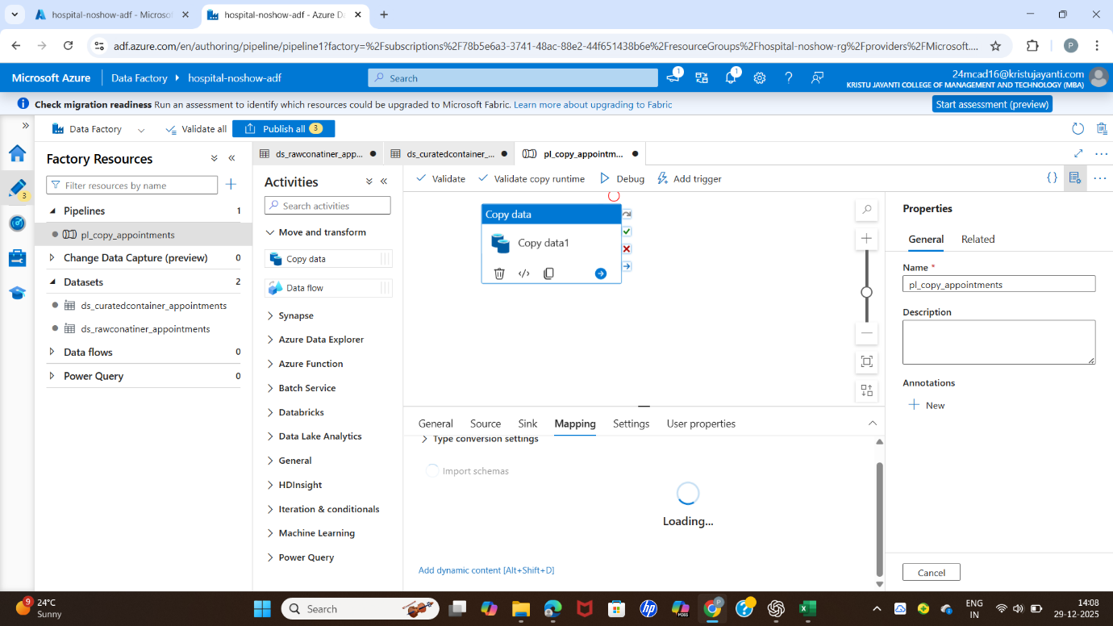

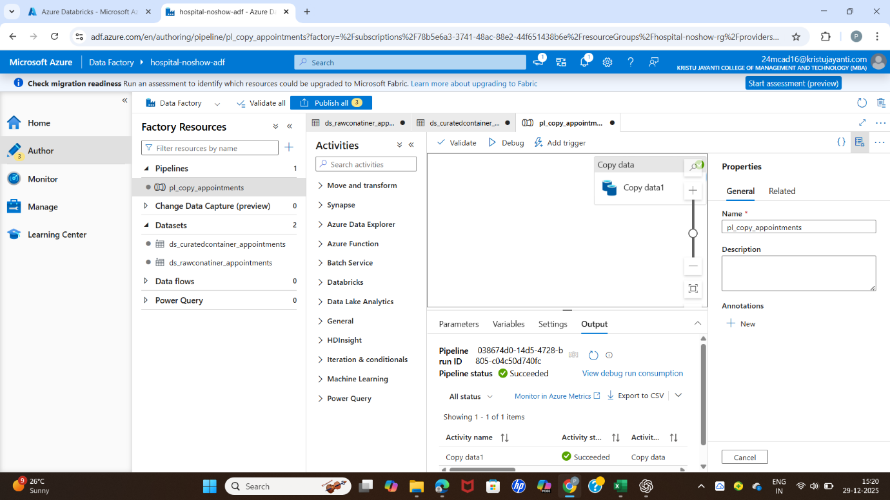

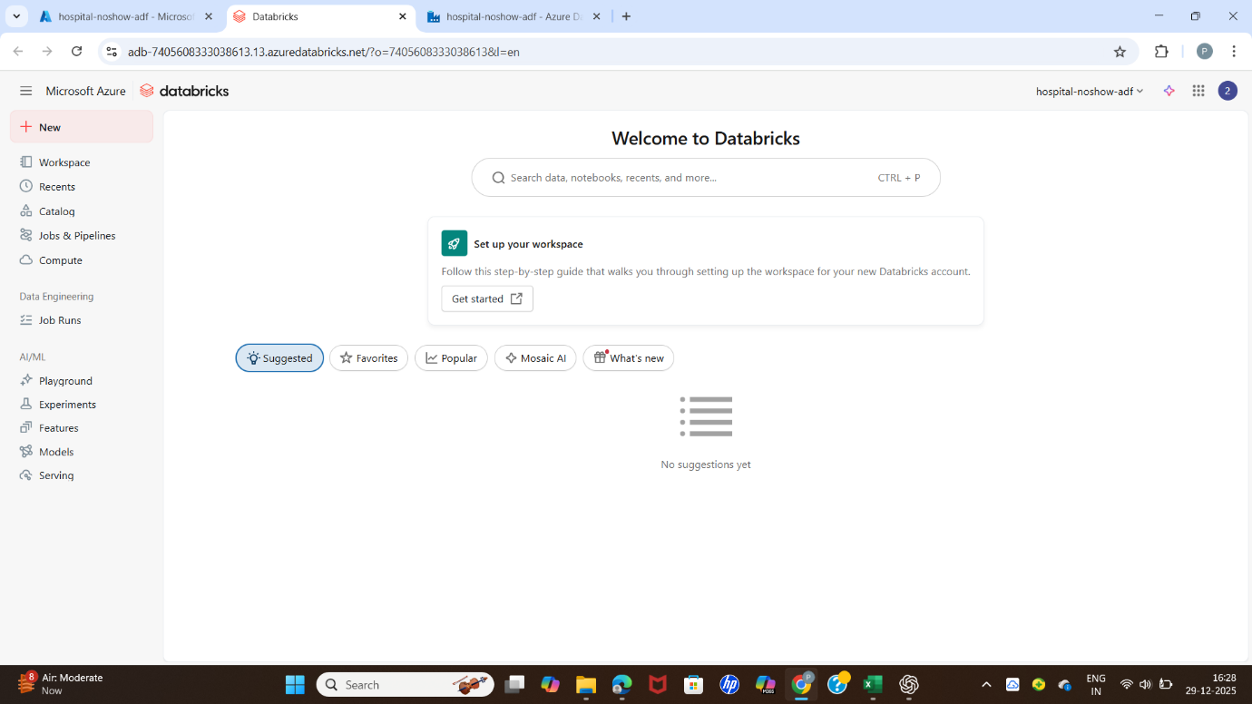

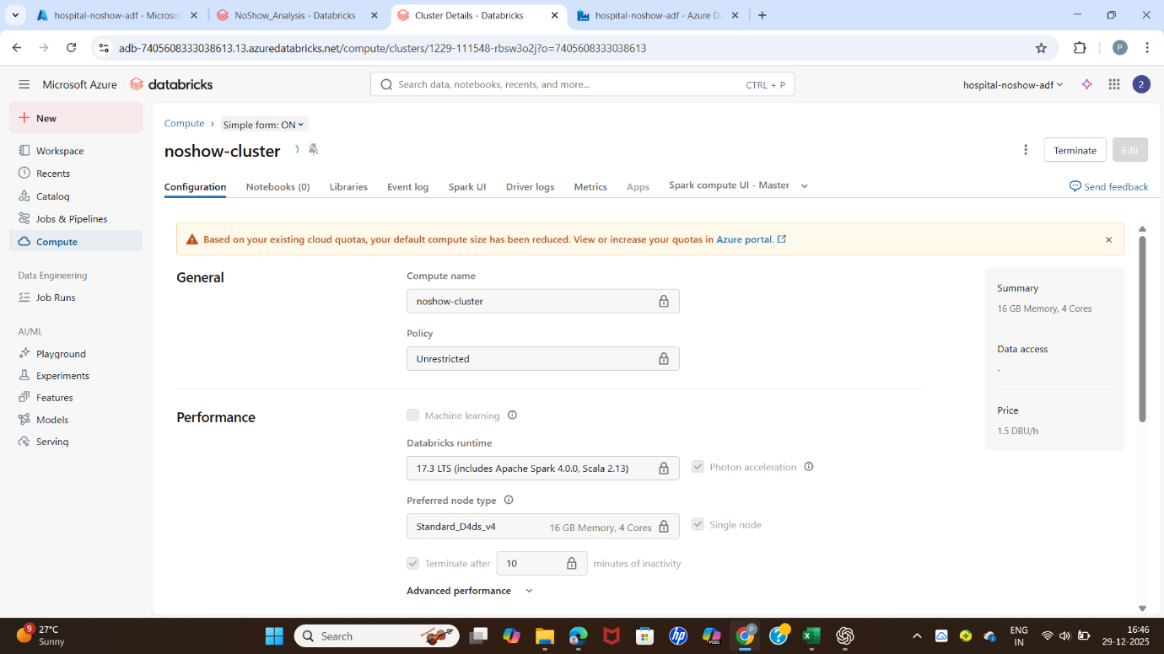

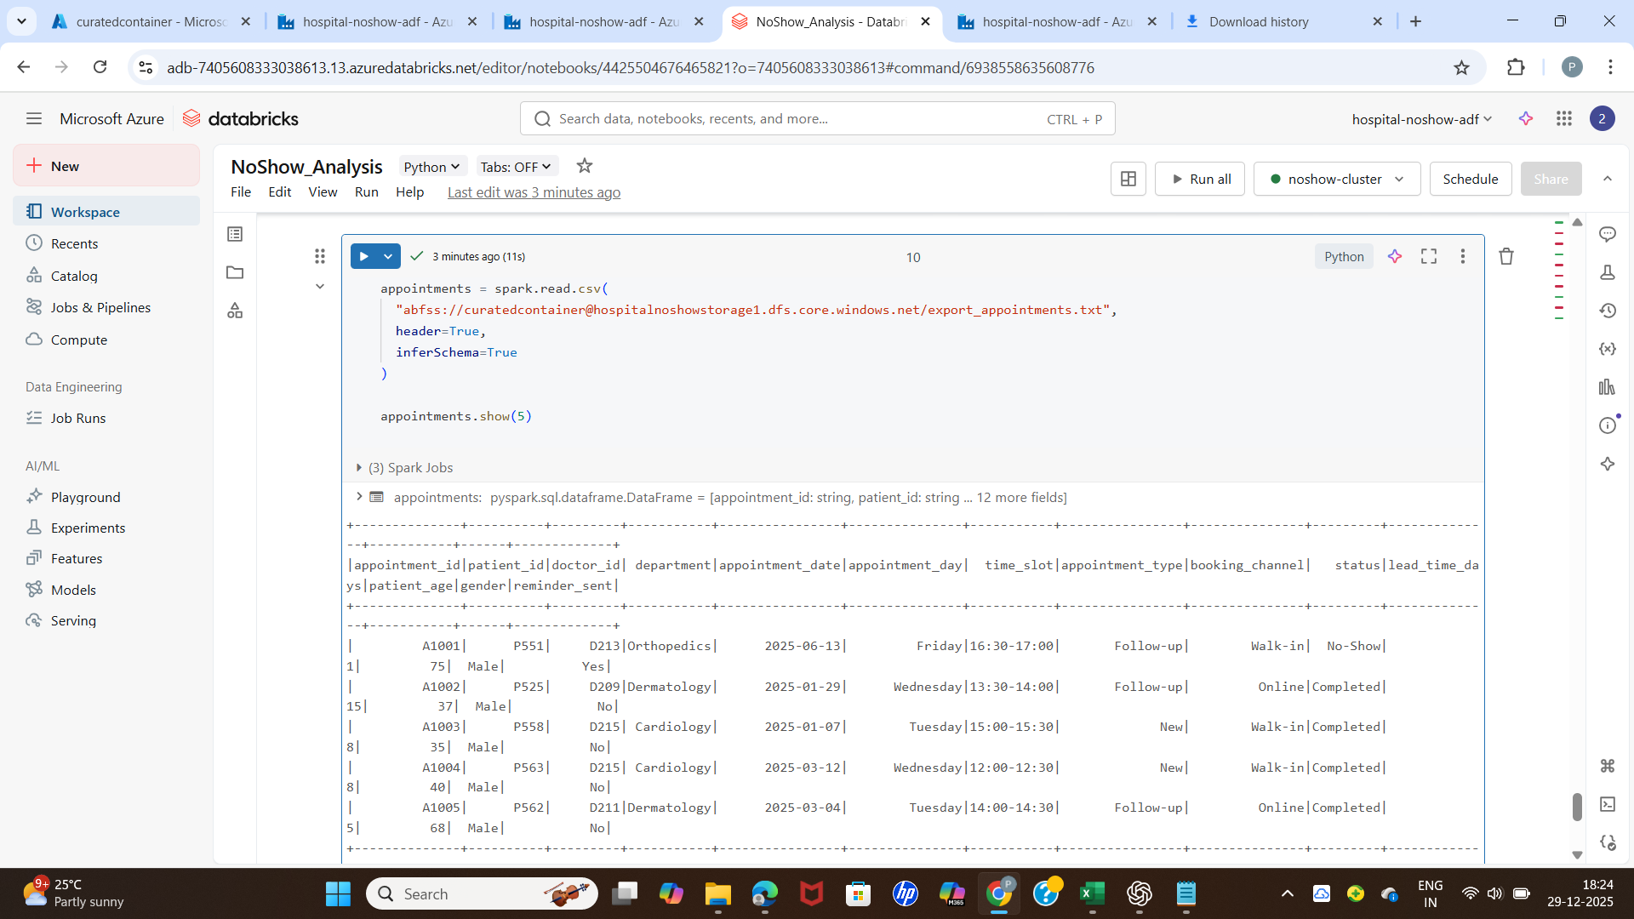

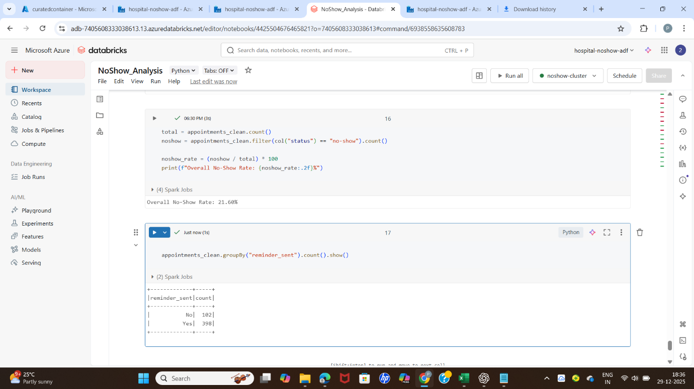

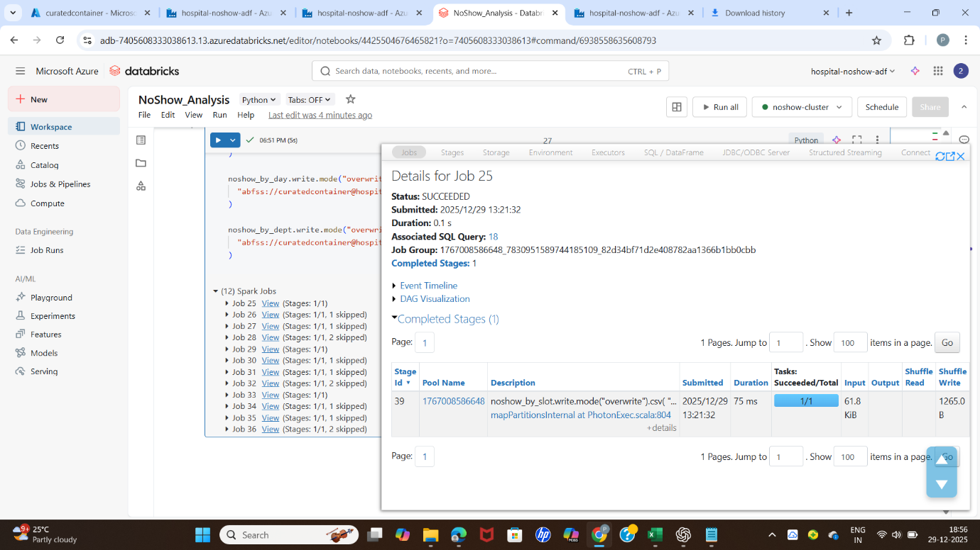

OUTPUT :

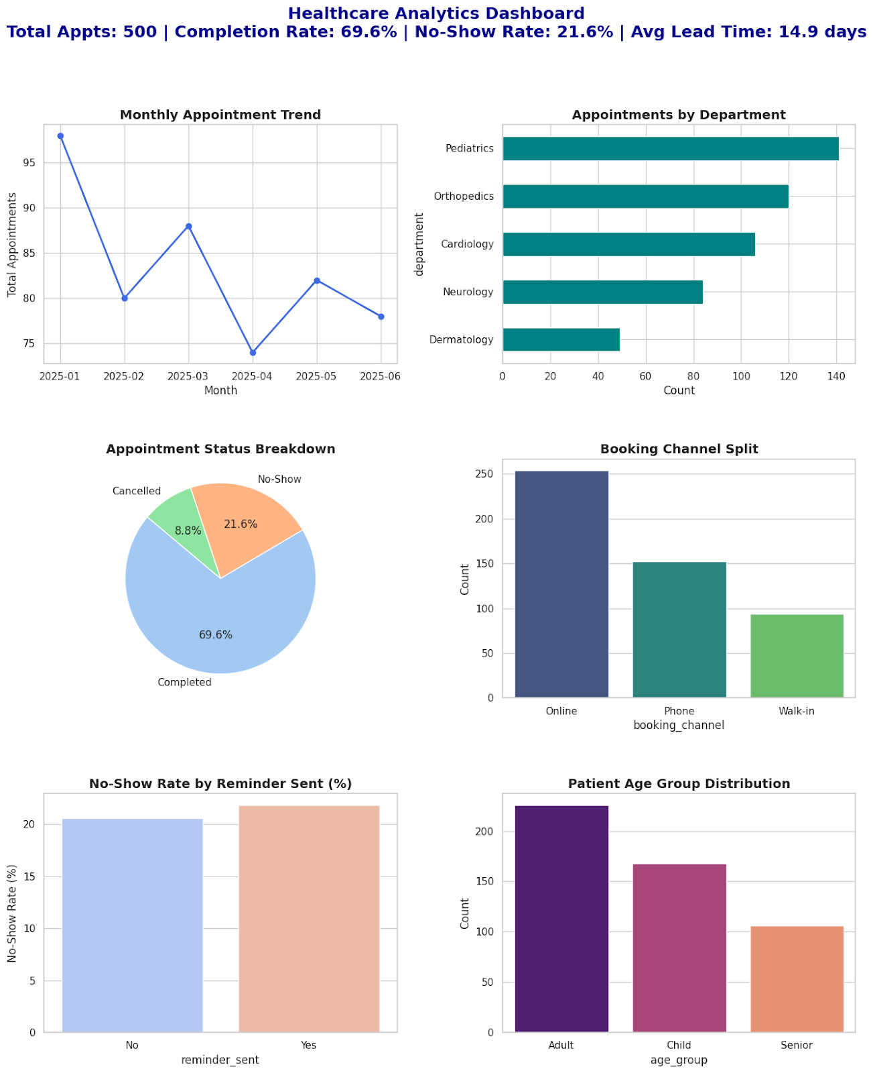

Conclusion
This project successfully demonstrates the design and implementation of an end-to-end cloud-based analytics solution for analyzing hospital appointment no-show patterns using Microsoft Azure. By integrating Azure Data Factory, Azure Data Lake Gen2, Azure Databricks, and Power BI, the project provides a scalable and automated pipeline for ingesting, processing, and visualizing healthcare appointment data.
Azure Data Factory efficiently handled data ingestion and movement, ensuring reliable availability of data for analysis. Azure Data Lake Gen2 served as a secure and scalable storage layer, while Azure Databricks enabled large-scale data processing and KPI calculations using PySpark. Power BI dashboards transformed analytical results into interactive visual insights, making complex data easy to understand for hospital administrators and decision-makers.
The analysis revealed meaningful patterns related to appointment no-shows, including variations by department, time slot, appointment lead time, and reminder effectiveness. These insights can help hospitals reduce appointment wastage, improve scheduling efficiency, optimize reminder strategies, and enhance overall patient care quality.
Overall, this project highlights the practical application of cloud analytics in the healthcare domain and demonstrates how modern data engineering tools can be leveraged to solve real-world operational challenges. The solution is scalable, flexible, and can be further extended with predictive analytics and real-time data processing to support advanced decision-making in healthcare organizations.

